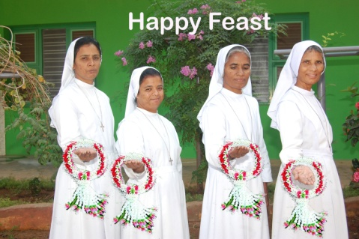
World Gratitude day -26.04.2016
Auxilium Ongole - INK

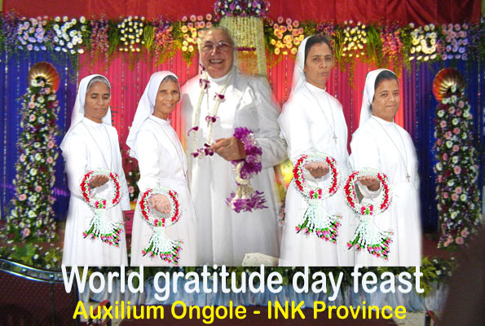
Carissima Madre
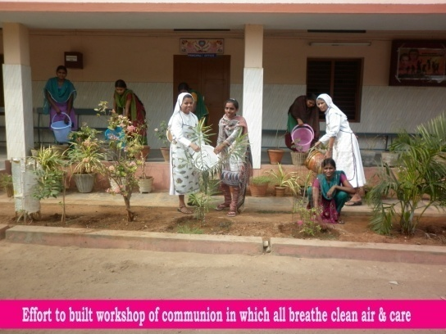
We Say “ Grazia Mille”
Here we begin with “Like a wreath in its diversity, the intertwining of life offered in mission in every corner of the world with grateful hearts”.
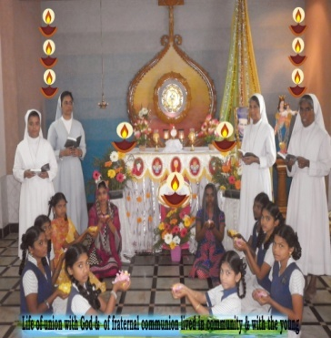
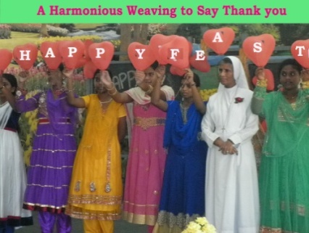
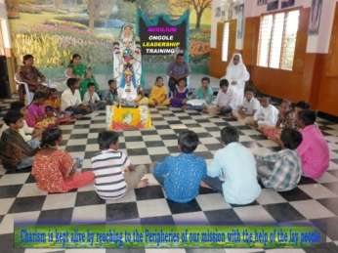
We raise our hearts with a hymn of unceasing praises and thanksgiving to God for YOU who is the Centre of great pearl of Communion in FMA institute all over. It is rightly said by Albert Sweitzr. “At times our own light goes out and is rekindled by a spark from another person. Each of us has cause to think with deep gratitude of those who have lighted the flame within us”. Yes, it is indeed you yourself who continuously try to rekindle the fire of love and communion in the hearts of each daughter of Mary Help of Christians and encourages us to be the living Monuments of Don Bosco gratitude to Mary Help of Christians and to make our communities homes of joy and hope like that of Mornese and Valdocco. Through your life of credibility, you walk the talk, have inspired us and enabled us to live the charism of our institute through your circular letters, encouragement, accompaniment, prayers and unconditional acceptance of our selves as we are
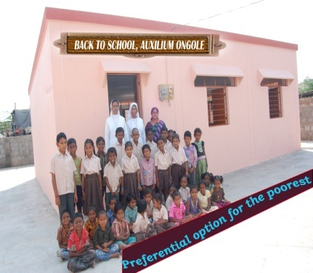
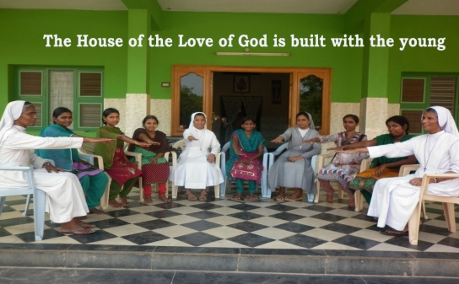
The theme of this gratitude has helped us to be grateful for the uniqueness of our individuality, difference of cultures and open to the realities and challenges of our life and the uncertainties of the future we are called to live-in harmony and build the communities of joy and hope. We as a community made a profound study on Acts of the General chapter, your inspiring circulars and Papal document-“Misericordiae Vultus”. We found in our community the following signs and ex pressions of Joy and Hope.
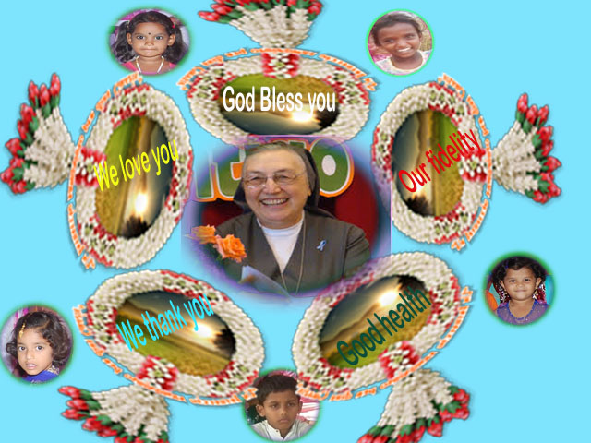

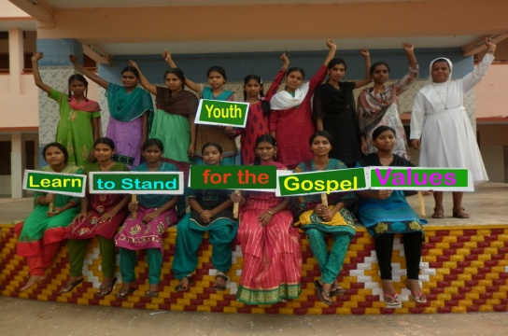

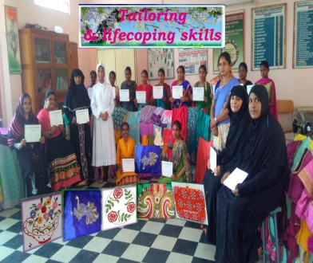

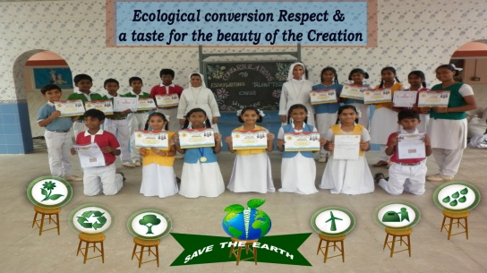
- Community rooted in Jesus, which is being nourished and strengthened by the Word of God , Strong Eucharistic and Marian
- Mission oriented, preferential option for the margins, women and the young
- Accepting each person’s uniqueness and practicing of mutual forgiveness.
- Making family visits, a source of evangelization and catechesis
- Responsible and joyful commitment to one’s duties and responsibilities
- Spirit of hard work and sacrifice
- Being always available for the mission
- Salesian formative presence according to the preventive system, among the young
- Salesian Joy and cheerfulness and family atmosphere.
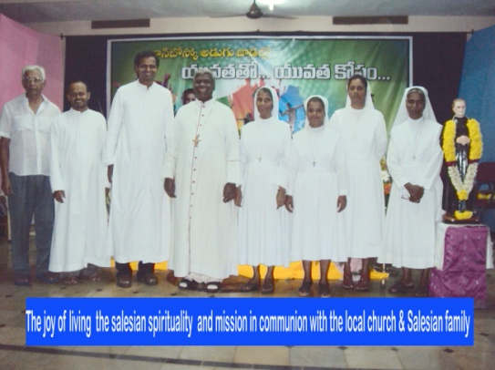
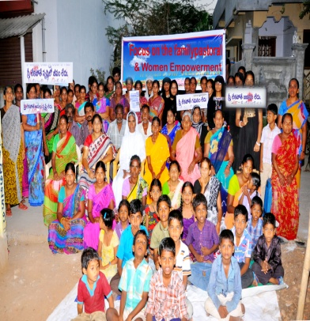
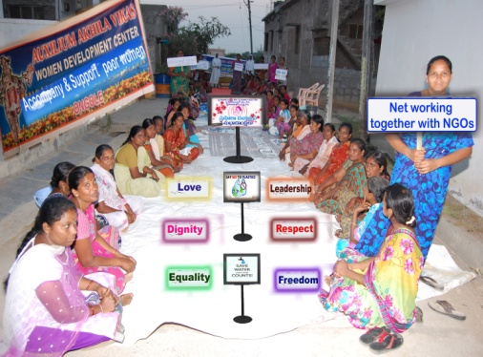
- Educating, Involving, encouraging, trusting in the good will of the young and helping them to become responsible for their life’s choices, future and share their resources with the needy and to become little missionaries among their peers.
